AIAC Assignment 2.3

Name: M Goutham
HT No : 2303A52010
Batch 31

Question
Task 1:
Word Frequency from Text File
Scenario: You are analyzing log files for keyword frequency. Task: Use Gemini to generate Python code that reads a text file and counts word frequency, then explains the code
Promt:

Create a Python program that creates a text file, writes sample text into it, then reads the file and displays its contents.
Add clear comments in the code.

code screenshot
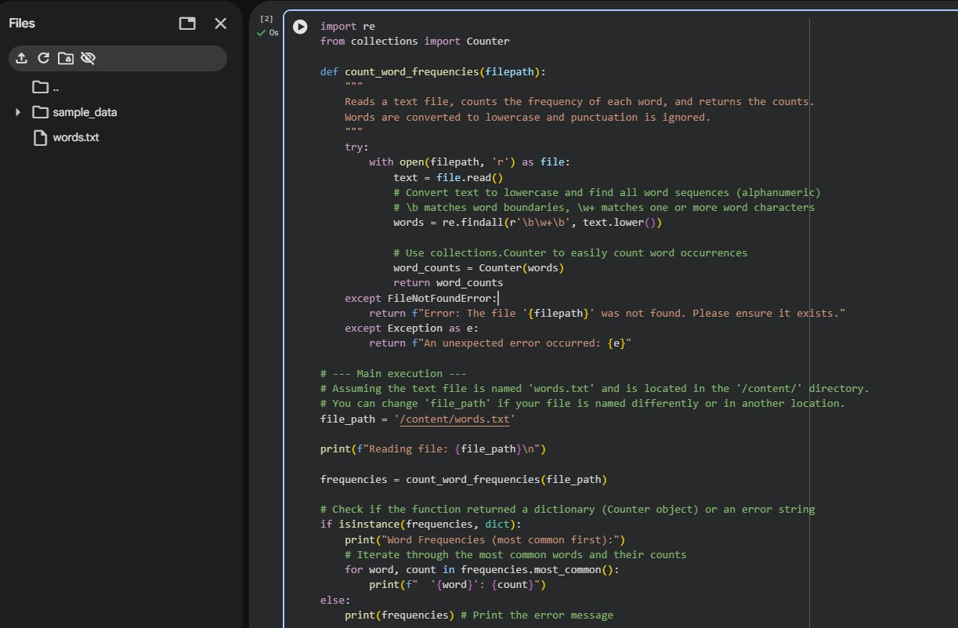
Output
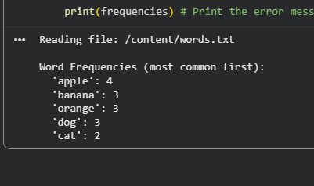

Explanation
In this program, a text file is read and the content is split into a list of words.
A dictionary is used to store them, where each entry maps a word to its number of occurrences.
Repeated words have their count incremented. At the end, the program prints how many times each word is found in the file.

Question

Task 2:
File Operations Using Cursor AI
Scenario: You are automating basic file operations.
Task: Use Cursor AI to generate a program that:
Creates a text file
Writes sample text
Reads and displays the content
prompt
generate a python program, which creates a text file, write sample txt eg.fruits in that, read and display that content.
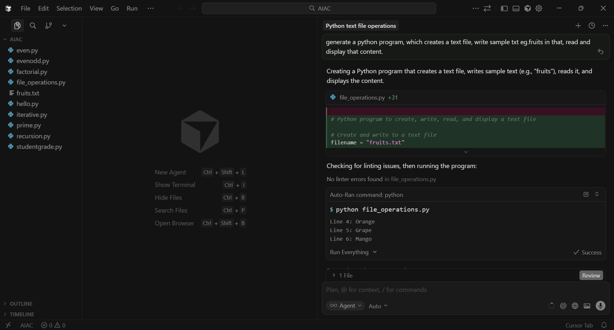

Code screenshot

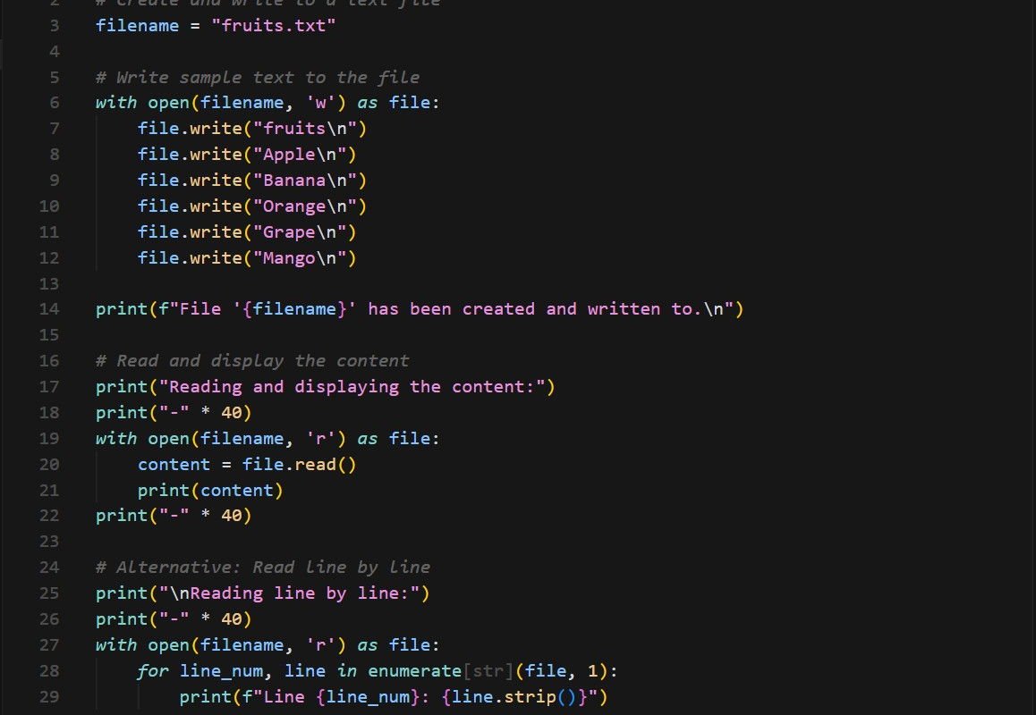

Output
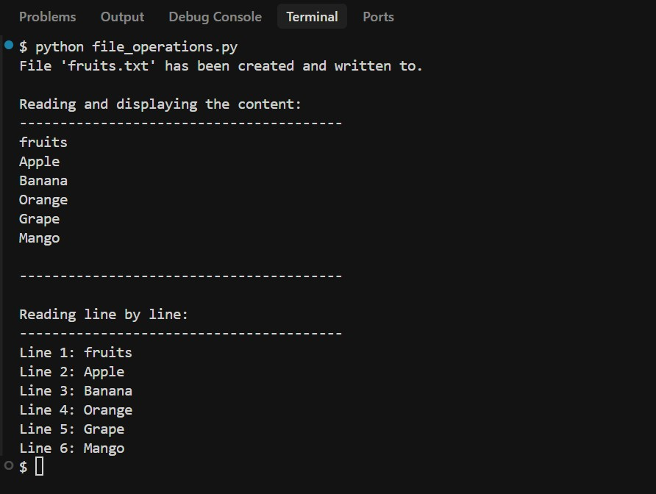
Explanation
In this program, Python’s cursor is used to demonstrate fundamental file handling.
A text file is created and filled with sample text, then reopened in read mode so its data can be displayed.

Question
Task 3: CSV Data Analysis
Scenario: You are processing structured data from a CSV file. Task: Use Gemini in Colab to read a CSV file and calculate mean, min, and max.

Prompt
Generate Python code to read a CSV file and calculate the mean, minimum, and maximum values of a numeric column.

Code screenshot
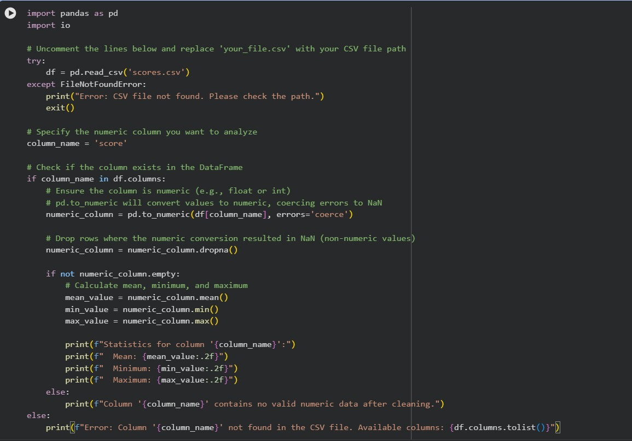
Output:
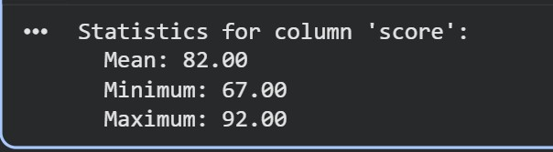
Explanation
This Python program opens a CSV file and collects numeric data from one of its columns.
It then computes statistics such as the average, minimum, and maximum values.
Analyzing CSV data is common in data science and various analytics tasks.

Question
Task 4: Sorting Lists Manual vs Built-in
Scenario: You are reviewing algorithm choices for efficiency.
Task: Use Gemini to generate:
Bubble sort
Python’s built-in sort() Compare both implementations.

code screenshot
Manual Bubble Sort Code:
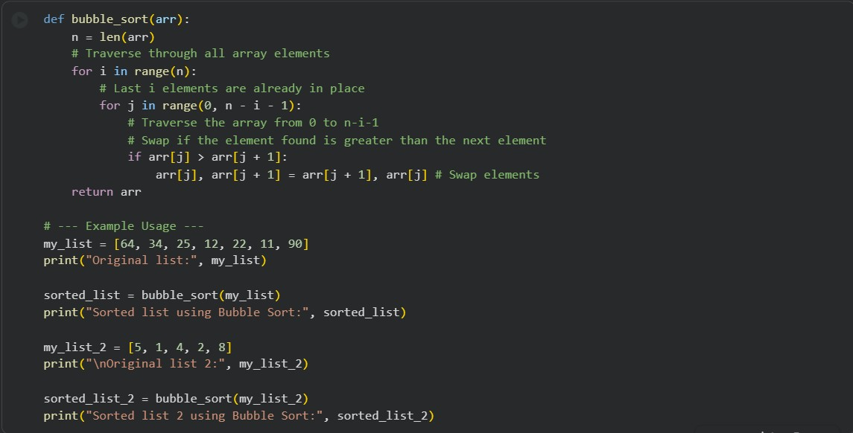
Sorting using sort() function:

output
Bubble sort:

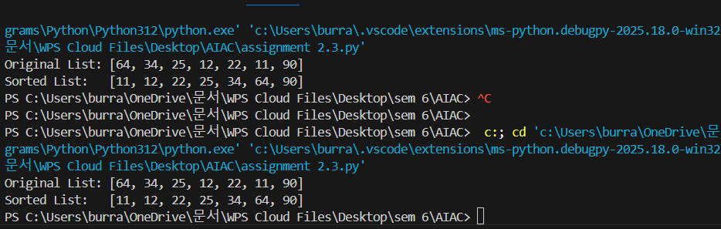

Sort Function:
Explanation
In bubble sort, elements next to each other are checked and swapped over and over until the list is sorted. This method is straightforward but slow when the input size grows. Python’s built-in sorting method is faster, more compact, and highly optimized.

